# 

# lab task

## Software Design and architecture

* **Name**: M. Aalyan Mughal
* **Reg** **No**: FA22-BSE-094
* **SECTION**: BSE 5B
* **SUBMITTED** TO: Sir Mukhtiar Zamin
* **Group** **Members** : Hassan Ali , Ghazi Raza

## pROJECT Name:

### Al-Powered Music Recommendation System

## Usecase diagram:

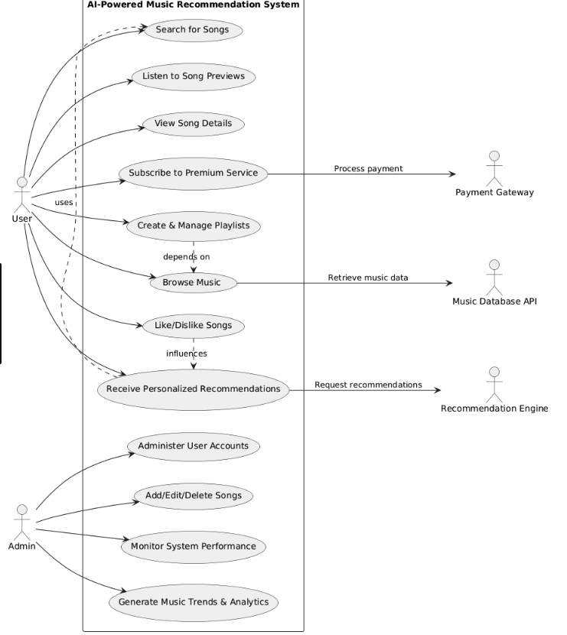

## Project report:

### GENERATE MUSIC TRENDS AND ANALYTICS

**Project Overview:**

This use case focuses on a feature within a larger AI-powered music recommendation system. The goal is to leverage user data to generate valuable insights into music trends and analytics, enhancing the platform's ability to provide personalized recommendations and improve user experience.

**Problem Statement:**

Music streaming platforms struggle to:

* **Understand emerging trends:** Identifying popular genres, artists, and songs in real-time can be challenging.
* **Provide tailored recommendations:** Knowing user preferences and trends allows for more relevant and engaging music suggestions.
* **Optimize content discovery:** Highlighting trending music helps users discover new artists and tracks they might enjoy.

**Solution:**

The "Generate Music Trends and Analytics" feature aims to address these challenges by:

* **Analyzing user data:** Tracking user behavior, such as listening history, playlist creation, and song skipping, to identify patterns.
* **Identifying trends:** Discovering emerging genres, popular artists, and trending songs based on data analysis.
* **Visualizing insights:** Presenting trends and analytics in a clear and actionable manner for both users and platform administrators.

**Key Features:**

* **Genre Trend Analysis:** Track the popularity of different music genres over time.
* **Artist Popularity Tracking:** Monitor the rise and fall of artist popularity.
* **Song Trend Forecasting:** Predict future popularity based on current trends.
* **Personalized Trend Recommendations:** Suggest trending music relevant to individual user preferences.
* **Data Visualization:** Provide interactive charts and graphs to visualize insights.

**Technology Stack:**

* **Data Storage:** Database system (e.g., PostgreSQL, MySQL) to store user data and analytics.
* **Data Processing:** Big data tools (e.g., Hadoop, Spark) for efficient data analysis.
* **Machine Learning:** Algorithms (e.g., clustering, regression) to identify patterns and trends.
* **Visualization:** Libraries for creating interactive dashboards.

**Design and Architecture:**

The system architecture involves:

* **Data Collection:** Gathering user data from various sources (e.g., streaming activity, playlist creation).
* **Data Processing Pipeline:** A pipeline that cleanses, transforms, and aggregates data for analysis.
* **Machine Learning Models:** Implementing models to extract trends and insights from processed data.
* **Visualization Engine:** Presenting analyzed data in a user-friendly format.

**System Workflow:**

1. **Data Collection:** Gather user data from various sources.
2. **Data Processing:** Cleanse, transform, and aggregate data.
3. **Trend Analysis:** Apply machine learning models to identify trends.
4. **Visualization:** Present insights in a user-friendly format.
5. **Recommendation Generation:** Provide personalized trend recommendations.

**Use Case Scenario:**

1. **User A** streams music regularly, creating playlists and rating songs.
2. **System** collects user data, processing it to identify trends.
3. **Trend Analysis** reveals a rising popularity of indie rock music.
4. **Visualization Engine** presents insights in a dashboard.
5. **User A** receives personalized recommendations based on trending indie rock music.

**Conclusion:**

The "Generate Music Trends and Analytics" feature enhances the AI-powered music recommendation system by providing valuable insights into emerging trends and user preferences. By leveraging user data and machine learning algorithms, the system can offer more personalized recommendations, improve content discovery, and optimize the overall user experience.

## Fully dressed usecase:

**Components of the Diagram**

**1. User Data Input**

* **Listening History**
  + Tracks played: Records each song played by the user.
  + Frequency of listening: Measures how often a user listens to specific tracks or artists.
  + Duration of play: Tracks how long users listen to each song.
* **User Preferences**
  + Preferred genres: Captures genres users enjoy the most.
  + Favorite artists: Identifies artists that resonate strongly with the user.
  + Playlist creation habits: Analyzes how users create and manage playlists.
* **User Feedback**
  + Likes and dislikes: Simple binary feedback on songs.
  + Ratings and reviews: Allows users to provide detailed feedback on songs or albums.
  + Social shares and comments: Tracks user engagement on social media platforms.

**2. Data Sources**

* **Music Metadata**
  + Genres: Information on various music genres associated with tracks.
  + Artists: Details about artists, including popularity metrics.
  + Release Dates: Historical context for trends based on when songs were released.
  + Album Information: Provides insights into albums associated with tracks.
* **External Trends**
  + Social Media Activity
    - Mentions and hashtags: Tracks engagement on social platforms.
    - Engagement metrics: Analyzes likes, shares, and comments.
  + Chart Positions
    - Billboard charts and streaming service rankings: Monitors song popularity across platforms.
  + Playlist Popularity
    - User-generated and curated playlists: Evaluates the popularity of playlists among users.

**3. Data Processing**

* **Data Collection Module**
  + Aggregates user data and music metadata: Combines internal and external data sources.
  + Real-time data feeds: Updates system with live data for timely insights.
* **Data Cleaning Module**
  + Handles missing values, duplicates, and outliers: Ensures data quality and consistency.
  + Standardizes data formats: Ensures compatibility across different datasets.
* **Feature Engineering Module**
  + Extracts relevant features (e.g., tempo, mood): Generates additional attributes to enhance model accuracy.
  + Derives composite features: Combines multiple attributes into meaningful scores (e.g., overall mood score).

**4. Analytics Engine**

* **Trend Detection Algorithms**
  + Time Series Analysis
    - Analyzes trends over time: Identifies rising or falling popularity of tracks.
  + Seasonal Decomposition
    - Identifies seasonal patterns: Detects regular patterns in music consumption (e.g., holiday music).
* **User Behavior Analysis**
  + Clustering Users
    - Segmentation based on listening habits: Groups users by similar listening patterns.
    - Identifies user groups (e.g., genre enthusiasts, casual listeners).
  + Sentiment Analysis on User Feedback
    - Analyzes text data for sentiment scores: Identifies general sentiment towards songs.
    - Trends in feedback: Monitors shifts in user sentiment over time.

**5. Visualization Tools**

* **Dashboards**
  + User-specific trends
    - Visualizes favorite genres over time: Graphs showing genre preferences across months.
    - Displays listening patterns: Time-of-day and day-of-week listening trends.
  + **Global trends**
    - Shows popular songs and emerging artists: Real-time updates on trending music.
    - Genre popularity shifts: Visual representation of genre dynamics.
* **Reporting Tools**
  + Generates insights for artists/labels: Provides actionable data for music creators.
    - Engagement metrics: Insights into listener growth and song popularity.
    - Feedback analysis: Highlights what elements of songs resonate with audiences.

**6. Output and Feedback Loop**

* **Recommendations Generation**
  + Personalized playlists: Uses trends to create tailored music suggestions for users.
  + Suggestions for new artists and genres: Introduces users to music aligned with their tastes.
* **Feedback Collection**
  + Gathers user interactions: Tracks likes, skips, and shares to refine recommendations.
  + Surveys and polls: Collects qualitative data on user satisfaction and preferences.
* **Model Retraining**
  + Periodically retrains models: Ensures the system adapts to new data and evolving user behaviors.
  + Updates to changing music landscape: Incorporates industry changes and new trends.

## SYSTEM SEQUENCE DIAGRAM:

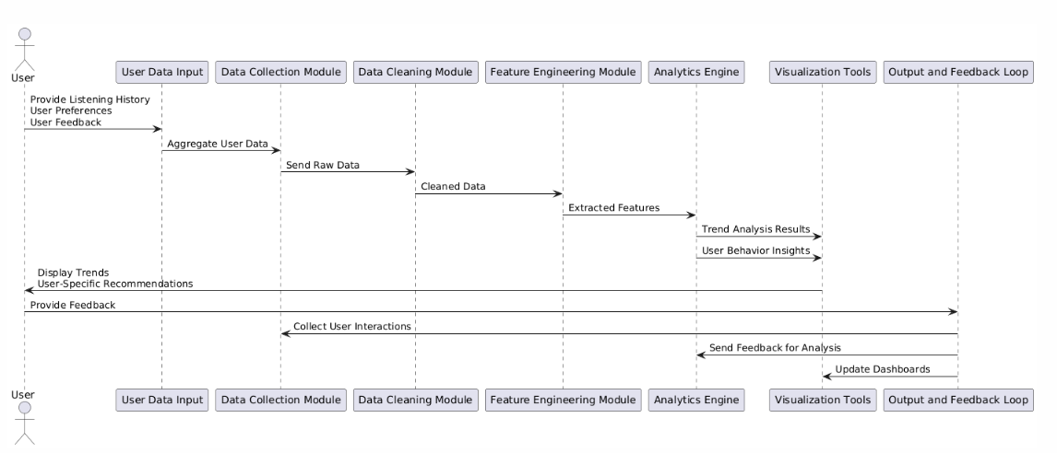

## COMMUNICATION DIAGRAM:

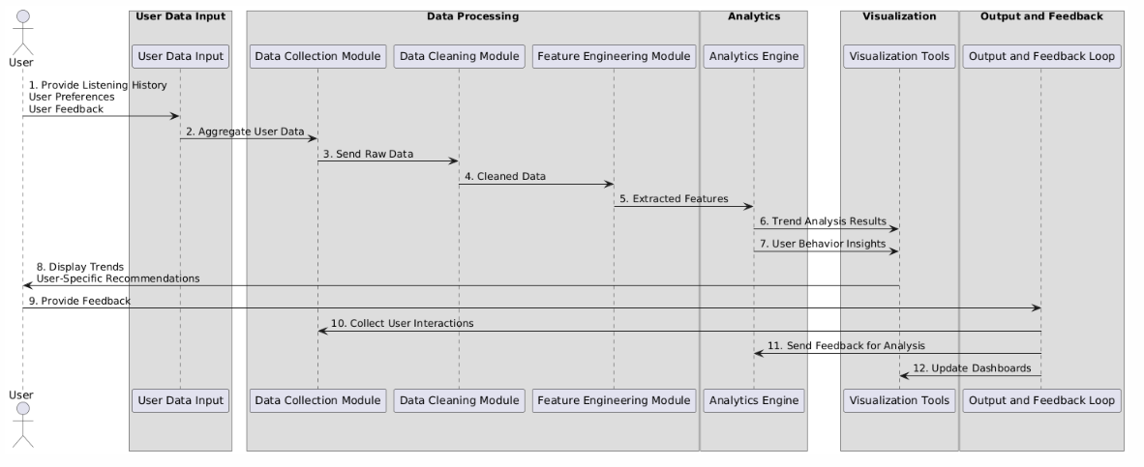

## CLASS DIAGRAM:

